ARCHITECT REVIEW
SCC-3387 | Create Outage Ticket
Great Plains Merge Sandbox | Read-only dry-run and readiness assessment
Environment | GreatPlainsMerge (Sandbox) | Org 00DEa00000GkAsHMAV
Review date | 26 August 2026
Retrieval | Succeeded | Job 09SEa00000iccfmMAA
Decision | Changes Requested - not ready for promotion
Boundary | No records, deployment, activation, or org metadata were changed

ARCHITECT DECISION
Do not promote yet. The Incident-based Outage path exists, but required data enforcement, severity values, NOC persona access, and queue membership are incomplete.

Acceptance outcome
# | Scope | Result | Evidence
1 | Incident and Outage type | Partial pass | Incident is available and Outage is active. It is visible/default only for System Administrator; the business NOC persona is not identified.
2 | Required outage fields | Fail | Five custom fields plus Detected Date Time exist, but all six are optional in schema, layout, and Dynamic Forms.
3 | Severity and narrative | Fail | Description and Created Date exist; Impact is required but still High/Medium/Low, not Minor/Major/Critical.
4 | NOC assignment | Partial pass | Active/latest before-save flow assigns new Outages to NOC. One existing Outage is NOC-owned, but the queue has zero direct members.
5 | NOC access | Fail | No NOC profile/role user is identifiable. Only System Administrator has usable create access and Outage record-type visibility.

Solution and control path
The platform objects and automation are present, but the intended NOC user cannot be proven and the record can be saved without the story's required operational data.
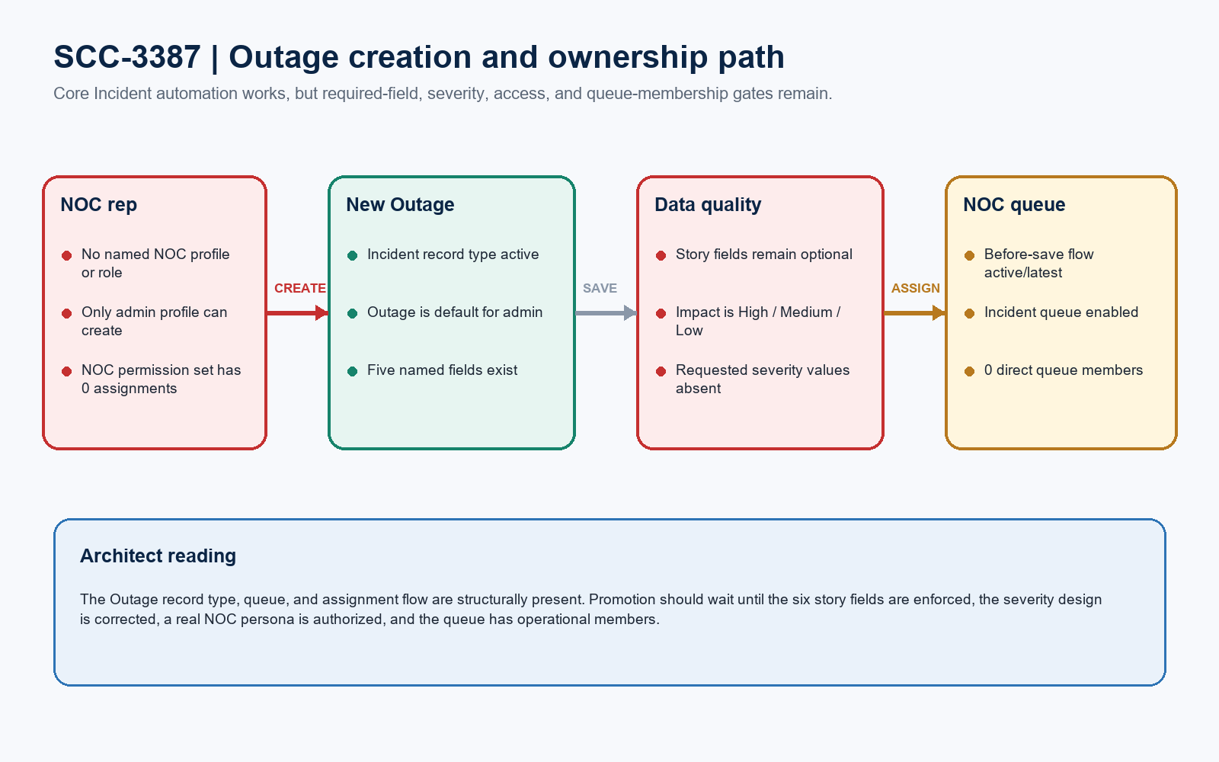
Figure 1. SCC-3387 outage creation and ownership path
DESIGN READING
Green is configured. Amber is structurally present but operationally incomplete. Red blocks acceptance.

Field and page configuration
Field | Configured type | UI behavior | Acceptance reading
Affected Area/Region | Text(255) | Optional | Fail - required by story
Equipment/Facility ID | Text(255) | Optional | Fail - required by story
Estimated Customers Impacted | Number(18,0) | Optional | Type passes; requiredness fails
Detected Date Time | Date/Time | Optional | Fail - required by story
NOC Ticket Number Reference | Text(255) | Optional | Fail - required by story
Estimated Restoration Hours | Number(18,0) | Optional | Type passes; requiredness fails
Impact | Restricted picklist | Required | Fail - High/Medium/Low, not Minor/Major/Critical
Description | Text Area(32,000) | Optional | Present; can hold description/cause if product confirms
Created Date | System Date/Time | Read-only | Pass - platform timestamps creation

Requiredness evidence
Layer | Observed configuration
Schema | All five SCC-3387 custom fields have required=false; DetectedDateTime is nillable.
Page layout | Only Subject, Status, and Impact are marked Required. The six story fields use Edit.
Dynamic Forms | Only Subject, Status, and Impact use uiBehavior=required. The six story fields use uiBehavior=none.
Severity | Outage record type enables Impact values High, Medium, and Low. Low is the default.

DATA QUALITY BLOCKER
A user can save an Outage without the six operational fields named as required in SCC-3387. Enforce the requirement at the Dynamic Forms/page layer or with a record-type-scoped validation rule.

Persona, queue, and automation evidence
Access path | Count | Observed permission | Architect interpretation
System Administrator | 41 active | Create/read/edit; Outage visible/default; fields editable | Technically works, but it is not a defined NOC least-privilege persona.
Standard User | 0 active | No Incident object permission; Outage invisible; fields read-only | Cannot execute the story.
System Administrator - API Only | 1 active | Incident create/edit; Outage invisible; fields editable | Integration persona, not a NOC business user.
SCC-3380 NOC permission set | 0 assignments | No Incident object permission and none of the five SCC-3387 fields | Does not close the SCC-3387 access gap.

Automation and operational readiness
Area | Result | Evidence
Assignment flow | Pass | Assign_Outage_Incident_to_NOC is active/latest (version id 301Ea00001jiGElIAM).
Trigger logic | Pass | Before-save on Incident create; checks Incident.Outage, looks up NOC queue, assigns OwnerId.
Existing evidence | Pass | One Outage exists and the aggregate ownership check shows it is NOC-owned.
Queue operations | Fail | NOC supports Incident and emails members, but it has zero direct members.
Runtime UAT | Not run | No test record was created or changed during this read-only review.

Component and evidence boundary
Boundary | Evidence
Focused retrieval | 16 metadata files including the Incident object container; job 09SEa00000iccfmMAA succeeded.
Ticket omission | Queue:NOC and FlexiPage:Incident_Record_Page1 are required to reproduce the reviewed solution but are absent from the ticket component list.
Ticket extras | Case.SendEmail and Case_Before_Insert_Update_Trigger_Flow do not implement the stated outage-creation acceptance criteria.
Validation boundary | No check-only deployment was run because this review retrieved current sandbox configuration and introduced no change package.

Required approval gates
# | Required action | Owner | Evidence needed
1 | Enforce required data | Admin / Product owner | Make the six story fields required for Incident.Outage and prove blank-save prevention.
2 | Resolve severity design | Architect / Product owner | Use Minor/Major/Critical on Impact or approve a documented alternative; regression-check Incident logic.
3 | Create NOC access model | Security owner | Grant named NOC reps least-privilege Incident create/read/edit, field edit, tab, and Outage record-type access.
4 | Populate NOC queue | NOC manager / Admin | Add approved users or groups and verify notification, list-view visibility, and ownership work routing.
5 | Correct component inventory | Release manager | Include Queue:NOC and Incident_Record_Page1; remove or justify unrelated Case components.
6 | Run named-persona UAT | QA / NOC | Create an Outage from Incidents, complete all fields, save, verify NOC owner, and capture record ID/screenshots.

Ready-to-paste architect response
STORY COMMENT
Architect review completed in the GreatPlainsMerge sandbox. Changes Requested: the Incident Outage record type, Incident-enabled NOC queue, and Assign Outage Incident to NOC flow are present, and the flow is active/latest. However, all six operational fields named as required can still be left blank; Impact remains High/Medium/Low instead of Minor/Major/Critical; only the System Administrator profile has a usable create path to Outage; the NOC queue has zero direct members; and the existing NOC permission set has zero assignments and does not grant the SCC-3387 object/field access. The ticket package also omits Queue:NOC and Incident_Record_Page1 while listing unrelated Case components. Complete the six gates above and rerun the story with a named NOC user before promotion. No records, metadata, activation, deployment, or production changes were made.

